Static Timing Analysis

Homework 1

Check whether there are setup/hold violations for the given circuit. Input signal waveform and circuit parameters are given.

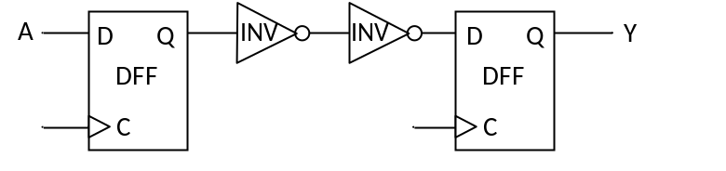

A
t(ns)
0
1
3.2
Parameter | Value
t_{setup,DFF} | 0.25ns
t_{hold,DFF} | 0.22ns
t_{cq,DFF} | 0.1ns
t_{INV} | 0.25ns
f_{Clock} | 500MHz

